PUCILLO FA MILY PRACTICE P.A.
WELLNESS CENTER
Family Medicine & Bariatrics
PFP CMPS December Newsletter:
COVID Testing
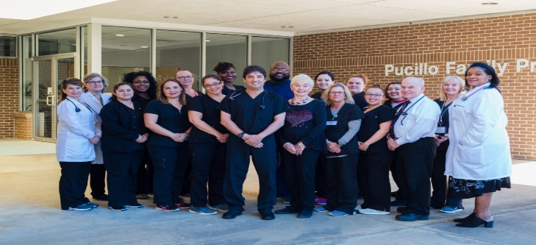 |  | Happy holidays from us to you.
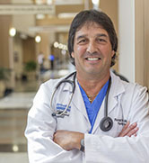 | Dr. Ron Pucillo, M.D. | 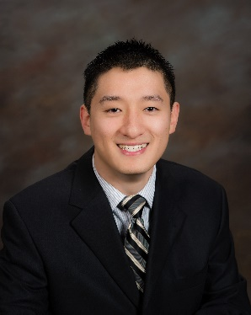 | Dr. Brian Tong, M.D.

COVID is back with positive and negative developments. There have been significant announcements on the vaccine front, and we will be providing you with updates on the vaccines in our upcoming Newsletter. (PFP’s Research division is operating clinical trials related to vaccines and therapeutics).
COVID Testing
All COVID tests are authorized by the USFDA under an Emergency Use Authorization (“EUA”). That means the FDA has not actually approved the tests according to normal approval processes and standards but has authorized them under a fast-track process that relies primarily on information provided by the manufacturer of the tests. In practice, that means there are variations between tests and the effectiveness data is constantly being updated. Always keep in mind that any test is not going to be 100% precise, neither in terms of false
positives not false negatives. In general, most tests currently employed can be expected to give a better than 95% confidence in the result, positive or negative.

The different types of tests for COVID-19 are grouped by their usage, here is a breakdown.
- PCR test
- Rapid test – rapid nucleic acid test and rapid antigen test
- Antibody test
 | 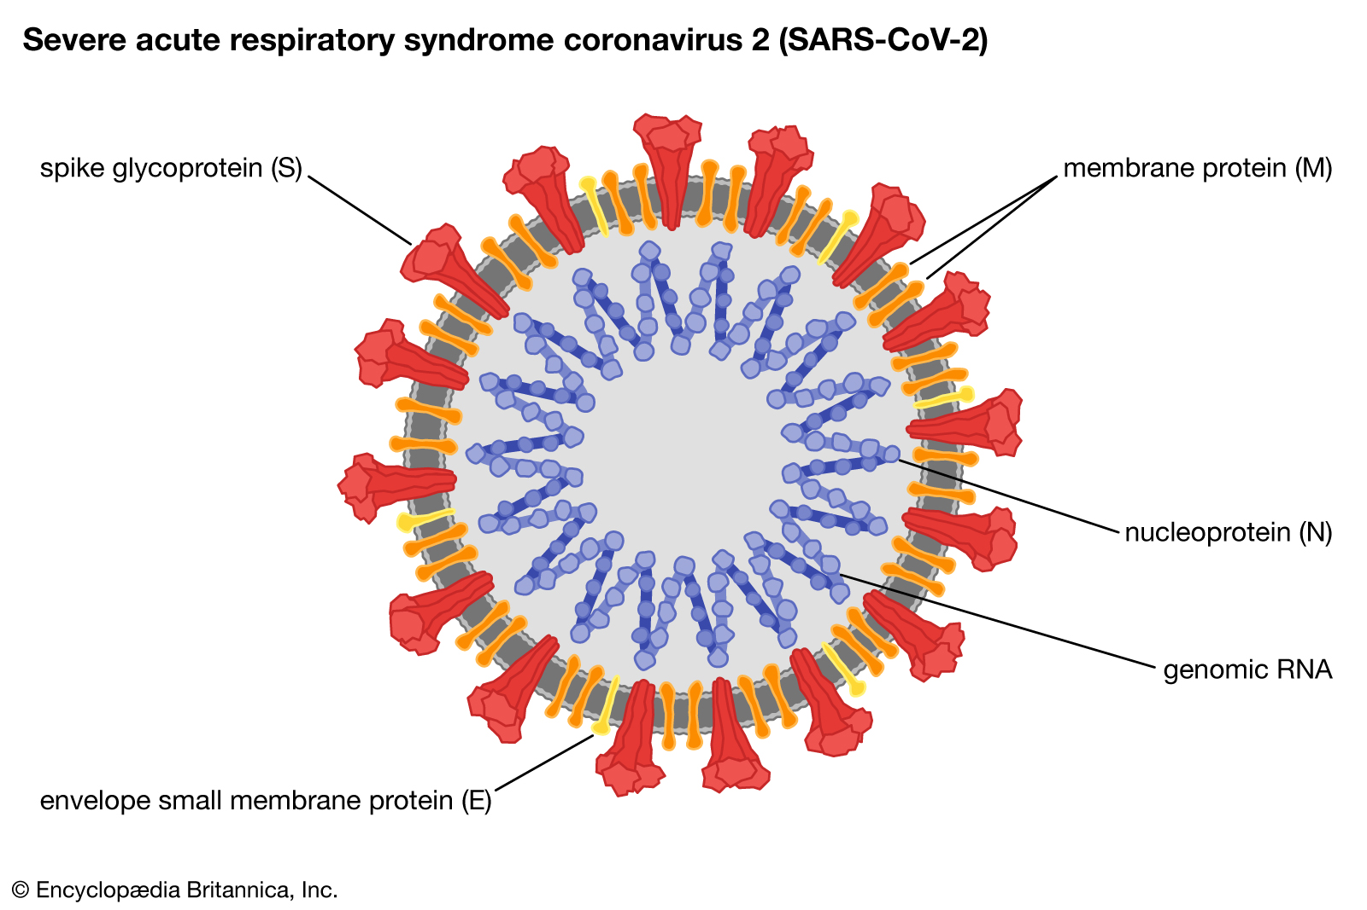 |  |  | 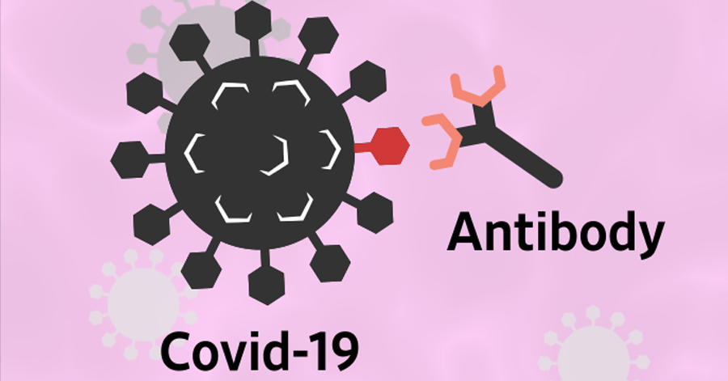
 | PCR test (nucleic acid test) | Rapid test (Antigen or nucleic test) |  | Antibody test
 | *Nasal or throat swab | *Nasal or throat swab |  | *Blood
 | *2-3 days | *15-30 minutes |  | *24-48 hours
 | *Identify active infection only | *Identify active infection only |  | *Identify active infection (IgM) and past infection (IgG)
 | *Most reliable, 99-100% accuracy (ISDA) | *less reliable, 75-94% accuracy (ISDA) |  | *Most reliable
- PCR TEST (nucleic acid)  The COVID-19 RT PCR stands for real-time reverse transcription polymerase chain reaction (RT-PCR) test. It tests for the qualitative detection of nucleic acid from SARS-CoV2 in upper and lower respiratory specimens ( such as nasopharyngeal or oropharyngeal swabs, sputum, lower respiratory tract aspirates or bronchoalveolar lavage). This is well established technology that uses temperature cycling for replication of specific parts of the nucleic acid to increase the quantity to detectable levels. A positive test result will depend whether viral RNA is in the collected sample, the amount of viral RNA, the sensitivity of the probe, the sensitivity of the detection method, and the number of times the test is cycled. Though nucleic acid tests are typically regarded as the “best” test for COVID, the result are dependent on good sample collection and handling. |  |  | 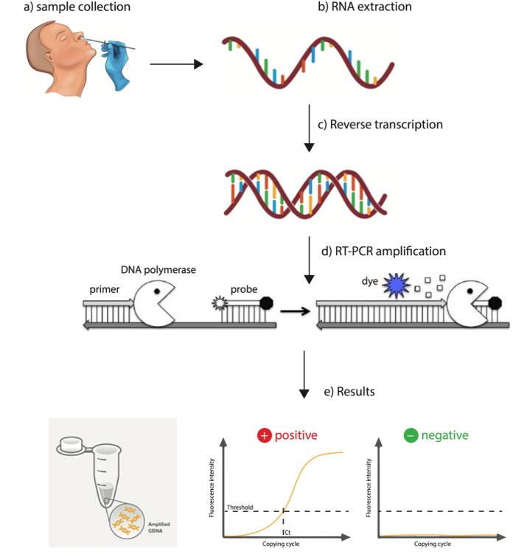
- The Rapid Diagnostic Test (RDT)  Detects the presence of viral proteins (antigens) or nucleic acid expressed by the COVID-19 virus in a sample from the respiratory tract. If the target antigen is present in sufficient concentrations in the sample, it will bind to specific antibodies fixed to a paper strip enclosed in a plastic casing and generate a visually detectable signal, typically within 15 to 30 minutes. If the strip shows a positive result, he patient would then know he is contagious and could quarantine at home. |  |  | 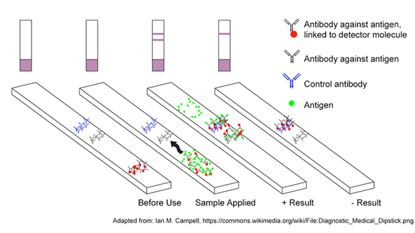
- ANTIBODY TEST (serology test).  Antibodies become detectable 1-3 weeks after symptom onset. Serologic tests detect current or past SARS-CoV2 virus infection by measuring a person’s immune response to the virus.  Antibody tests, detect presence of IgM and IgG antibodies in the blood. IgM antibodies are produced rapidly, and indicate an “acute infection”. IgG antibodies – which are the predominant kind – take longer for the body to produce, and their presence indicates if the body has immunity to the infection.  Example:  IgM (-), IgG (-) – no current or previous infection  IgM (-), IgG (+) – no current infection, has had previous infection  IgM (+), IgG (+) – current infection, body is starting to build immunity |  |  | 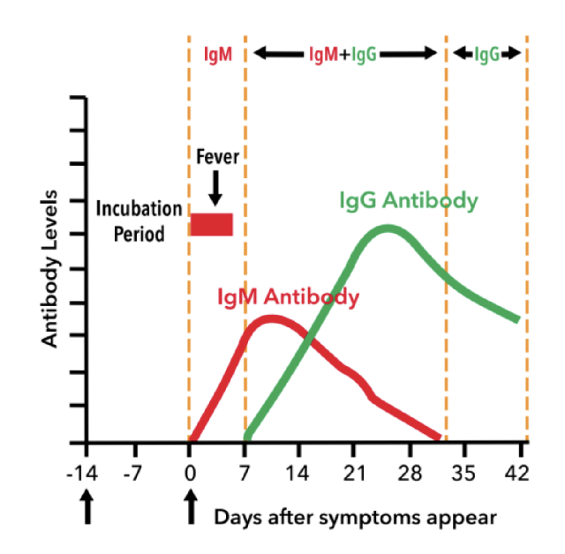

Chinese embassy travel requirements updated on November 5, 2020 (http://www.china-embassy.org/eng/notices/t1829922.htm):
- The nucleic acid test (PCR-RT) & IgM anti-body test
- Both tests must be done within 48 hours before boarding.
- If you are flying to China via connecting flights, you will need to take the tests a second time when transiting, and apply for the HDF/HDC from the Chinese Embassy/Consulates in the transit country if it is required. It will take some time for the Embassy/Consulates to process the application. Please schedule your tests in advance and apply for the HDF/HDC as soon as the negative test results are received.
·The test report must be an official certificate of the test institution and include the following essential information: patient name, date of birth, test type, date of sample collection, test result, name of test institution, contact information of test institution, date of sample collection must be stated in the certificate.
·The test certificates can be in print or in digital form. If the essential information, such as patient name, date of birth, date of sample collection and test result, is handwritten on the certificates, they will be deemed invalid.
·Passengers are recommended to take a hard copy of the test certificates with them in case of airline inspection or other usages.
Travel planning
Travelers to China require a PCR test along with an IgM test within 48 hours before the flight. PFP, in conjunction with United Medical Memorial Center (UMMC) hospital, is able to offer this service. Please make proper arrangements for testing as PCR test may take up to 48 hours to result.
If your flight leaves on a Friday at 2pm, you must come to be tested Wednesday at 2pm or after. Since you need a doctor’s orders for the test, an appointment with a provider is required the day before on Tuesday. This can be done via telemedicine. Meanwhile your sample will be delivered to the lab and the testing expedited. Results will be available within 24-48 hours, at which time you can submit the results to the embassy.
In the meantime, please continue to practice social distancing, do not meet in large crowds, always wear a mask and wash your hands frequently.

